PAINSHILL’S BIG EASTER EGG DESIGN COMPETITION
Fun and colourful characters are coming to Painshill this Easter holiday. Large statues of painted eggs will include a Cow, a Hen, a Pirate and a Unicorn.
We have one egg however that is blank and we need your ideas!
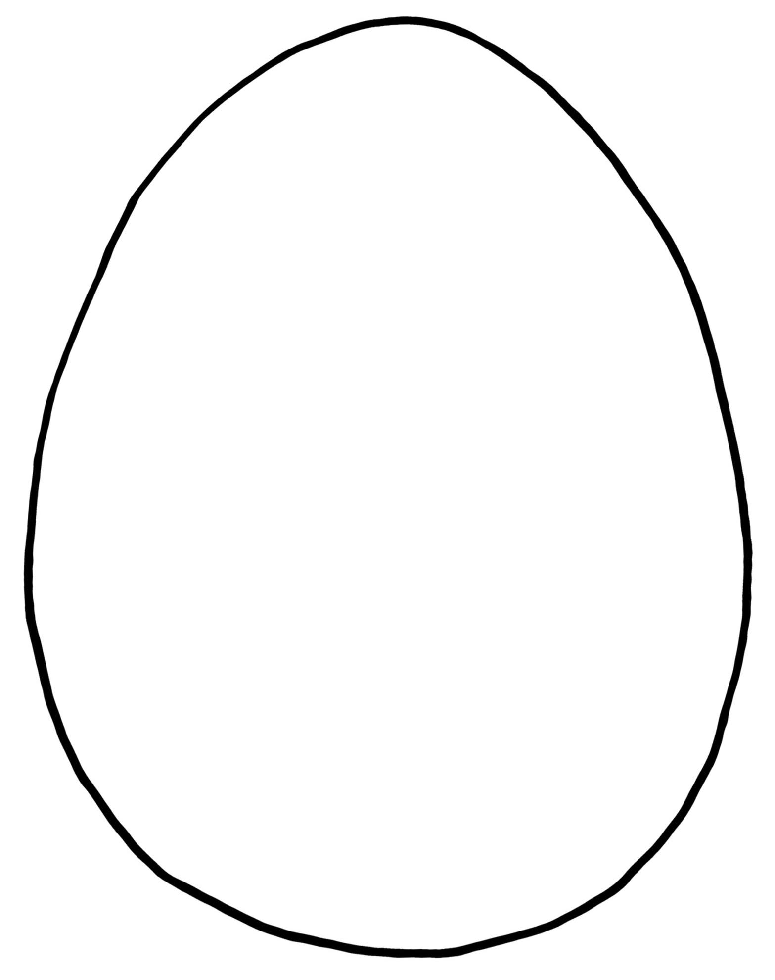
Design your egg character and email it to marketing@painshill.co.uk to enter
Your name...........................................................................................................
Your email address..........................................................................................
We will take the winning design and have it painted onto a huge egg to feature in our trail.
The winner will receive free tickets to Painshill to come and see their design in the landscape this Easter.
The competition is open to all ages and closes on Friday 25 February.

